Association of State and Territorial Dental Directors
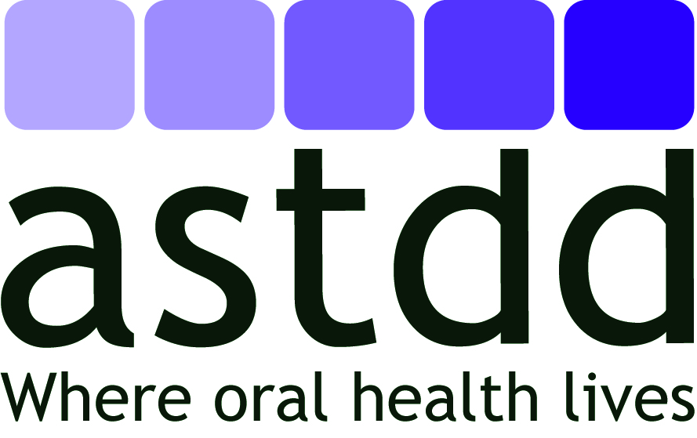

National Center on Health, Behavioral Health, and Safety

Meeting Report Form

Name of Meeting:
Location:
Dates:
Person Reporting:
Presenter(s):

- Purpose of meeting/conference (target audience and number of participants):

- Identify key points:

- New information relevant to state, local or community dental programs:

- Information of importance to ASTDD as an organization:

- Suggestions for future interactions with this group:

- Other comments:

