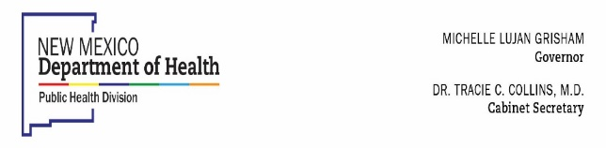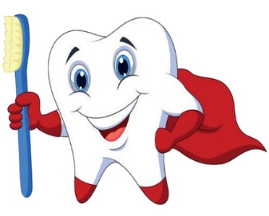

**ATTENTION PARENTS!!**

**Protecting your child safely!**

The New Mexico Department of Oral Health is excited to provide exceptional preventive oral health services for your child during this COVID-19 time. We would like to inform of the following changes for the safety of our staff and your child, and to adapt to the changing time of COVID 19. Always feel free to contact our office with any questions or concerns.

Get more info about our response to COVID-19 at https://cvnmhealth.org

**Personal Protective Equipment:**

All oral health staff will wear a N-95 and surgical masks while providing services, as well as protective eye wear, face shields, disposable gowns, and gloves. All students and oral health staff are also required to wear a mask when there are no active services.

**Infection Control:**

Our program requires all oral health staff to wash their hands and use hand sanitizer consistently, we will continue to use the best safe practices of infection control and adhere to cleaning and disinfecting protocols.

**Social Distancing:**

Oral health staff and students must maintain a six-foot distance from each other whenever possible. Students will be called in one at a time to allow extra cleaning/disinfecting time between students.

**Screening your child:**

Students will be screened for COVID-19 symptoms and temperature checks will be taken.

**Screening of Oral Health Staff:**

Oral health staff will also be screened for COVID-19 symptoms and temperature checks will be taken prior to services.

If you have any questions, please call the Office of Oral Health in Santa Fe at (505) 827-0837

in Albuquerque at (505) 841-5872 or in Las Cruces at (575) 528-5087

HELP KEEP YOUR CHIL’S TEETH HEALTHY!