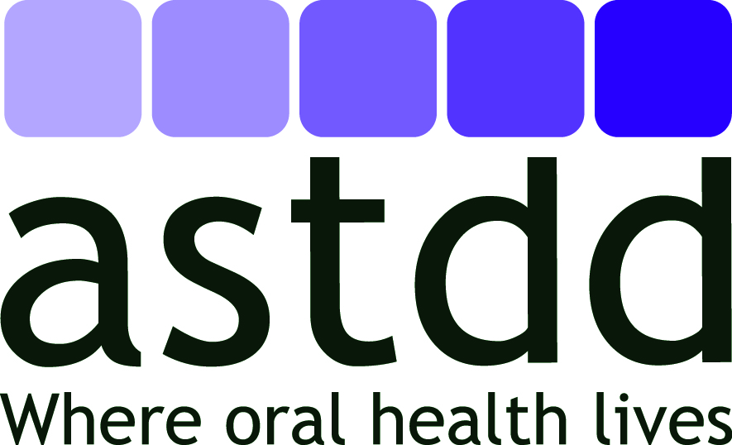
COMMUNICATION PLAN: BEST PRACTICE APPROACH
STATE ORAL HEALTH PROGRAM WORKFORCE CAPACITY DEVELOPMENT

Instructions: Prepare one plan for each goal.
Problem Statement | People are the foundation of the public health infrastructure. For a public health system to be effective, adequacy is needed both in numbers and skills to ensure an optimal supply of new and seasoned, well-prepared public health professionals. The ideal dental public health infrastructure should also use personnel in an effective and efficient manner. State Oral Health Programs (SOHPs) vary in size, structure, funding, staffing, location within the health agency hierarchy and focus. A successful SOHP needs a complement of staff, consultants and partners to achieve an adequate and competent workforce. These professionals may or may not have formal training or credentials in public health or dental public health, or be dentists, dental hygienists or other oral health care professionals. An inter-professional approach, incorporating professionals from multiple disciplines, is needed to attain all of the skill sets and workforce hours required to provide all the essential services to promote oral health.  To meet this challenge, SOHPs must develop and utilize best practices. Most SOHPs have few employees and relatively small budgets yet are able to conduct a remarkable number of activities with support from other health programs and community partners. Unfortunately, there are insufficient incentives to entice entry into dental public health and few career ladders in dental public health or in SOHPs.
Goal | Increase awareness and knowledge of the need for and strategies to achieve increases in state oral health program workforce capacity development
Target Audience(s) | 1)State oral health programs; 2) Federal agencies; 3)national organizations such as ASTHO, ADEA, AAPHD, ADHA, ADA, ASPPH, ANOHC; 4) third party payors
Objectives | 1) By 8/31/2016 at least 5 SOHPs will use the BPAR to increase use of proven and innovative recruitment and retention strategies and leverage new expertise and resources to increase program capacity and sustainability; 2) By 8/31/2016 at least 5 national organizations that influence career choices and options will promote and share the BPAR and emphasize the benefits and diversity of roles and job/learning opportunities in state oral health programs.
Key Messages | - Inconsistent or interchangeable use of terms has created long-standing debate about who is considered a “public health professional” or a “dental public health professional.” Until there are clearer definitions around credentials, work settings, or the skills needed to perform specific scopes of work, confusion and disagreement will continue to interfere with high quality evaluation studies or other public health research pertaining to the state public health workforce  - Currently there are few incentives or certification programs to entice dentists or dental hygienists into public health or to work in state health departments.  - Students of all levels are essential to the future pool of SOHP workers.  - SOHPs must reach beyond their silos to assure the full complement of skill sets and competencies. Resource sharing and collaborative partnerships can help SOHPs accomplish equal or greater health improvements without overburdening understaffed agencies.  - Along with new skills needed, the following attitudes are needed by public health workers: 1) openness, 2) selflessness, 3) political sensitivity, 4) values differences and 5) learning spirit  - Retention of current SOHP workforce or tapping into the retired workforce talent pool prevents the loss of long-term experience, maintains community connectedness, and keeps the institutional memory of highly experienced staff.  - Providing mentoring and continuing education opportunities for the current health agency and SOHP workforce is important to ensure the competency of the workforce and to increase staff engagement.  - Strategic workforce planning is an important human resource process to make sure agencies have the right number of people with the right competencies in the right jobs at the right time.
Planned Channels and Materials | Post to website; National org email distribution list with attached BPAR and also website link; panel presentations at NOHCs and APHA; highlight in OHM, weekly digest and 1 pager; tipsheet, policy resource document; webinar based on recommendations, strategies and state submissions
Plan for Pre-testing Messages and Materials | BPAR workgroup, BP committee, BOD review, retired dental director, 2 health officers
Planned Activities and Timelines | Present at NOHC (4/15); at APHA (11/15); 2016 NOHC (4/16); develop 1 pager of BPAR for these presentations (4/15, 10/15, 4/15); post on ASTDD website (12/15?); develop tipsheets on some of the topics (4/16); develop lessons learned/success stories to share via ASTDD, ASTHO, CDC etc communication pathways (8/16); plan and conduct webinar as FU to NOHC presentation around challenges and potential strategies (summer 2016); discuss at DPH residency directors/residents meeting at NOHC (4/16); write ASTDD PH policy statement based on BPAR (fall 2016)
Evaluation Design, Methods and Measures | annual member and partner surveys and any targeted queries; webinar or panel evaluations; new state practice submissions or other success stories highlighting strategies and lessons learned
Responsible Parties and Partnerships | BPAR workgroup and any subgroups, BP committee, Communication committee, webmaster, ASTDD ED
Budget/Resources Needed | Consultant time, printing of tipsheets and one-pagers, travel to meetings for presentations
Protocol for Review and Approval | BPAR workgroup, BP committee, BOD review
Progress Notes: Panel was presented at 2015 NOHC; panel accepted for APHA and slides being created; descriptive submissions collected and reviewed; 2016 NOHC abstract accepted as ASTDD plenary session; one pager done for 2015 NOHC panel.
Definitions

Problem Statement: A short paragraph that describes the need for the communication strategy based on some form of needs assessment and baseline data. Determine data sources and use relevant information. Describe the rationale for the strategy to be used, including references to relevant theories, "best practices" or evidence-based approaches.

Goal: A brief sentence about the overall health improvement you strive to create.

Target Audience(s): The audience(s) selected for program messages and materials. The primary intended audience consists of those individuals the program is designed to affect. The secondary audience is the group (or groups) that can help reach or influence the primary audience. Conduct or review research about the audiences through literature reviews, key informant interviews, surveys and other means.

Related concept: Audience Segmentation. Subdividing an overall population into homogeneous subsets in order to better describe and understand a group, predict behavior and tailor messages and programs to match specific interests, needs or other group characteristics. Segments may be demographic, (e.g., lifestyle, use patterns, risk factors, values and beliefs, benefits sought) or based on a combination of these factors.

Objectives: The specific outcomes you expect exposure to your communications will produce in support of the program’s overall goal. A should be Specific, Measurable, Achievable, Relevant and Time Bound (SMART).

Key Messages: These are brief statements directly tied to goals and objectives, sometimes accompanied by visuals, that present key aspects of the communication strategy (e.g., action to be taken, benefits promised in exchange, support for the benefit) to the intended audience(s). Message concepts often differ in terms of the type of appeal used, e.g., factual, emotional, demonstrating the action to be taken. Consider characteristics of the intended audience such as the health literacy, values and beliefs and cultural attributes.

Planned Channels and Materials: The route(s) of message delivery (e.g., mass media, interpersonal channels such as health professional to patient, community events such as health fairs) and type of materials, e.g., print (fact sheet, educational brochures, report) or electronic (podcasts, video, e-newsletter, social networking, webinar).

Plan for Pre-testing Messages and Materials: Systematically gathering target audience reactions to messages and materials before they are produced in final form, paying particular attention to literacy levels, values and beliefs and cultural differences. This can be done through focus groups, individual interviews or feedback forms. Use feedback to refine messages and strategies prior to final release. Messages and plans for materials can be tested before materials are developed; draft materials can be tested after development.

Planned Activities and Timelines: The methods and steps proposed to implement the communication strategy. These might include media briefing and/or kickoff event, distributing promotional materials at health clinics, release of report and posting on website, presentation and conference, etc. Multiple, integrated strategies are most effective. With respect to timelines, estimate when you will start and end the activities. Make sure your timelines are realistic. Timelines should be clear and renegotiated as needed.

Evaluation Design, Methods and Measures: The overall approach, methods and measures used to assess the extent to which a program achieved its objectives. They should address questions such as the following: What should the members of the intended audience think, feel or do as a result of the communication strategy, in comparison to what they thought, felt or did before (at baseline)? How has their oral health status improved? What were some of the variables that interfered with success? Were there any unintended benefits or effects? Measures and method should be realistic.

Responsible Parties and Partnerships: Individuals or programs responsible for each aspect of the plan; this includes outside partners.

Budget and Resources Needed: An estimate of what each step may cost in terms of materials and staff or consultant time. Determine in-kind contributions. Develop options depending on resource level/limitations. Determine if additional resources are needed and how they will be acquired, e.g., grants, donations, cost-sharing with partners.

Protocol for Review and Approval: The individuals/office that need to approve communications produced by the oral health program. Outline which steps or materials need approval at what level; factors that process and any revisions into overall timelines.

Progress Notes: Actions taken to achieve the stated objectives and results achieved. Also record any changes to the plan.

