Worksheet 6. SAFAR Ratings of Your Program/Group and Partners
Use ratings outlined on the next page
CURRENT (C) and DESIRED (D) LEVELS OF INTEGRATION (0-4) (SAFAR)  Date: __________________ | Your Program/Group  Current Desired
Group 1:
Group 2:
Group 3:
Group 4:
Group 5:
AVERAGE CURRENT (C) AND AVERAGE DESIRED (D) LEVELS OF INTEGRATION

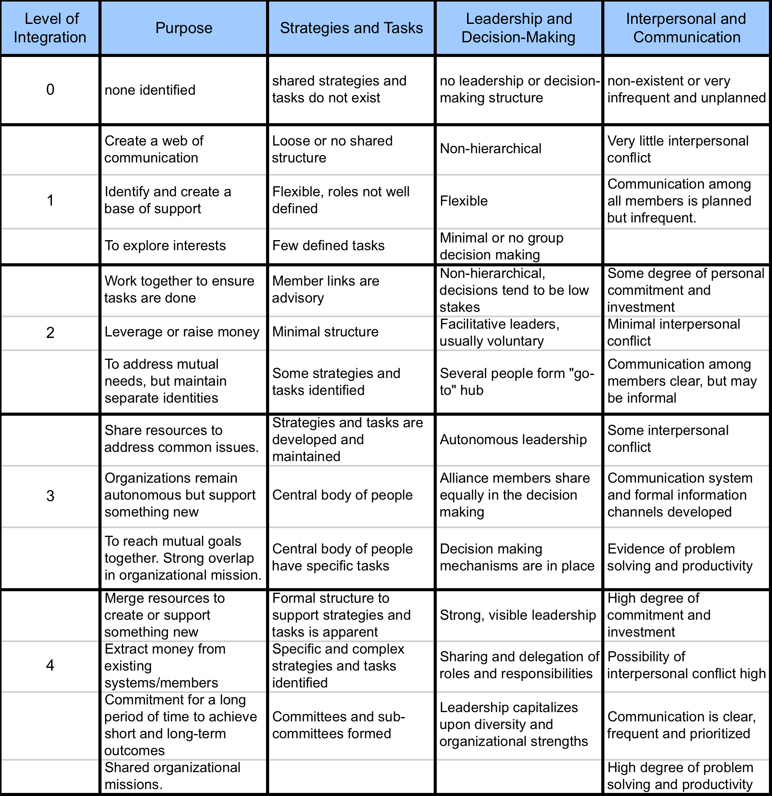
Strategic Alliance Formative Assessment Rubric--SAFAR

