Worksheet 7. SAFAR Alliance Assessment
Use ratings outlined on the next page

Current (C) and Desired (D) Levels of Integration  Date: | Group 1 |  | Group 2 |  | Group 3 |  | Group 4 |  | Group 5 |  | Group 6 |  | Group 7
 | C | D | C | D | C | D | C | D | C | D | C | D | C | D
Group 1:

Group 2:
Group 3:
Group 4:
Group 5:
Group 6:
Group 7:
Average Current (C) Level Across Alliance: |  |  |  |  |  | Average Desired (D) Level Across Alliance:

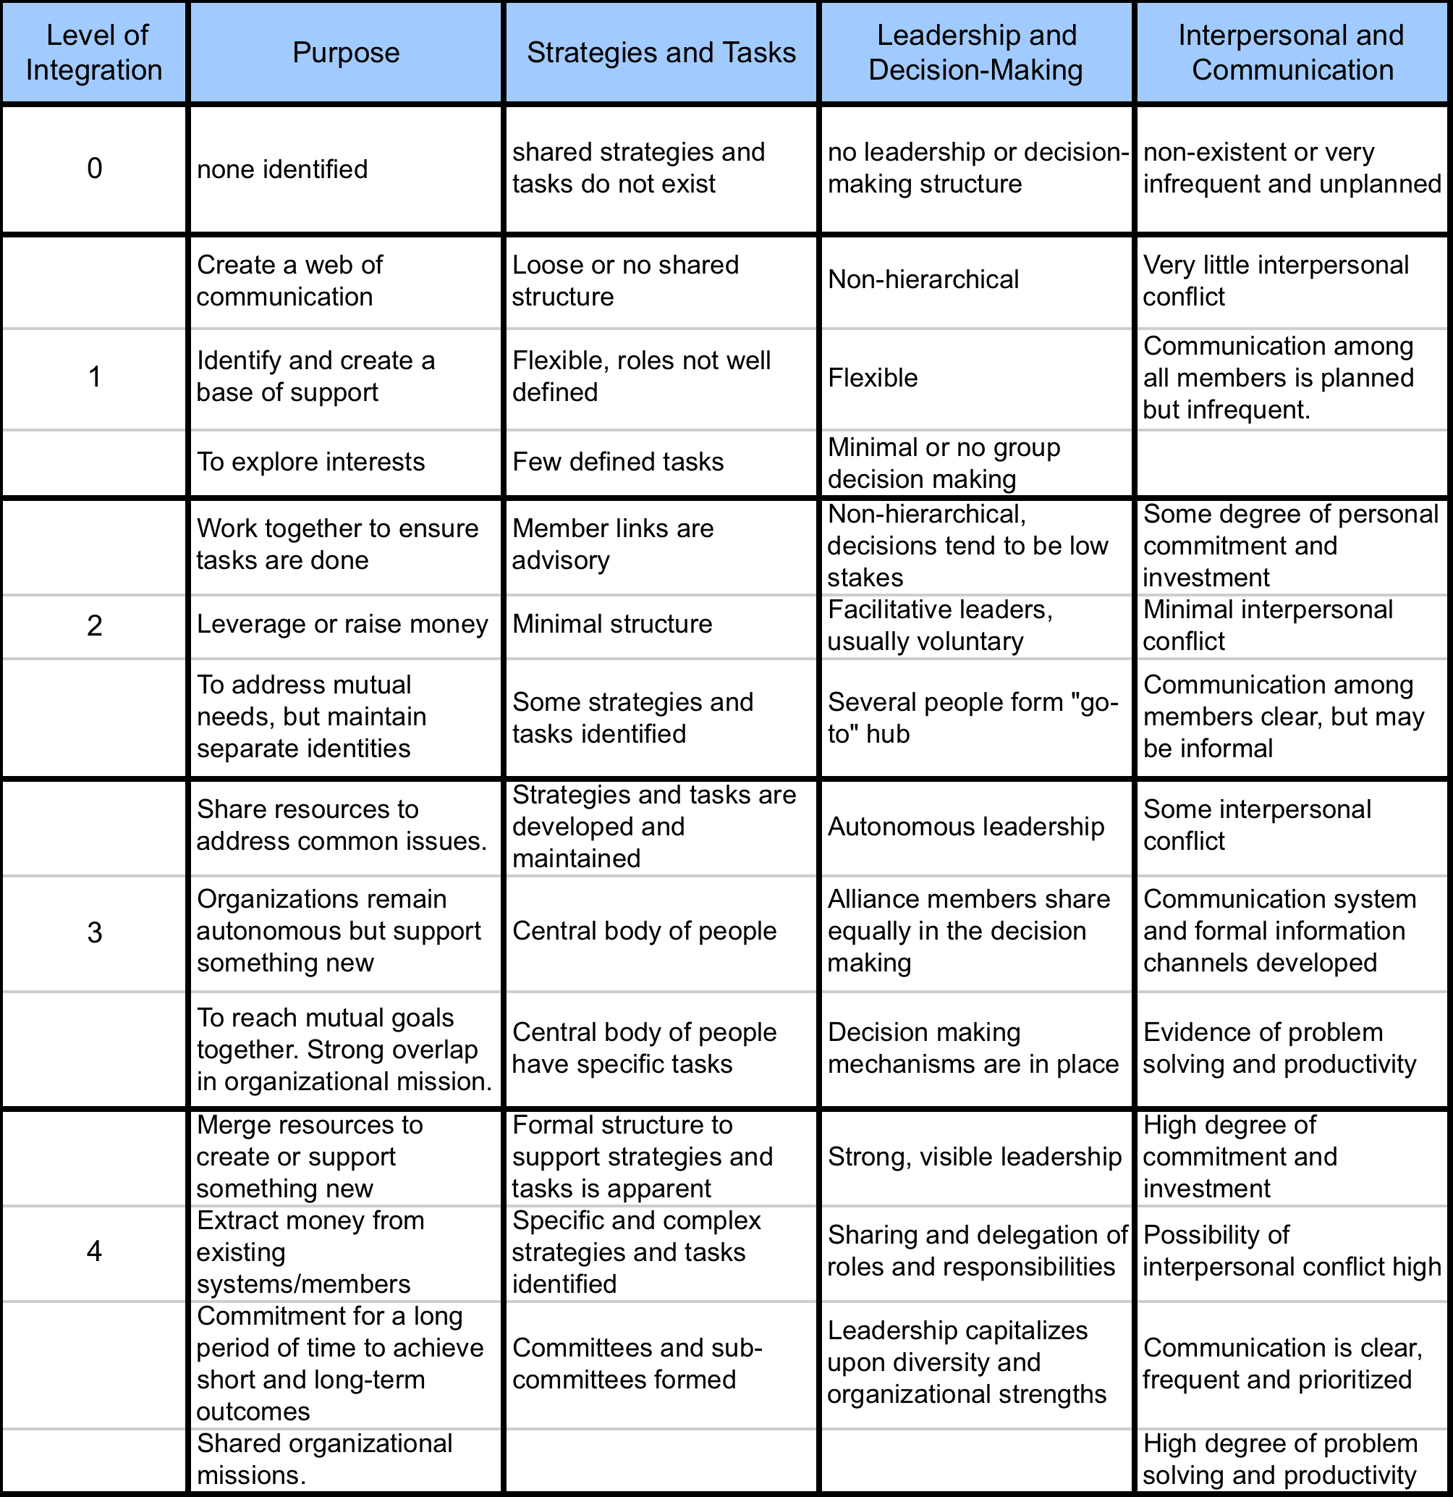
Strategic Alliance Formative Assessment Rubric--SAFAR

