Appendix E.

Personal Preparedness

Pandemic Preparedness

Personal preparedness involves three essential steps:
1. Get a kit.
2. Make a plan.
3. Stay informed.
The following text and templates are from the Ready Gov. website
Get a Kit
When preparing for a possible emergency situation, it's best to think first about the basics of survival: fresh water, food, clean air and warmth.
Recommended Items to Include in a Basic Emergency Supply Kit:
- Water, one gallon of water per person per day for at least three days, for drinking and sanitation
- Food, at least a three-day supply of non-perishable food
- Battery-powered or hand crank radio and a NOAA Weather Radio with tone alert and extra batteries for both
- Flashlight and extra batteries
- First aid kit
- Whistle to signal for help
- Surgical masks & a dust mask, to help filter contaminated air
- Disposable gloves
- Disinfectant sprays and wipes, sanitizer, hand sanitizer
- Plastic sheeting and duct tape to shelter-in-place
- Moist towelettes, toilet paper, garbage bags and plastic ties for personal sanitation
- Wrench or pliers to turn off utilities
- Can opener for food (if kit contains canned food)
- Local maps
- Cell phone, tablet, laptop with chargers/cords

Additional Items to Consider Adding to an Emergency Supply Kit:
- Prescription medications and glasses
- Infant formula and diapers
- Pet carriers
- Pet food and extra water for your pet; litter and box if needed
- Important family documents such as copies of insurance policies, legal documents and identification, passport and bank account records in a waterproof, portable container
- Cash (especially change), credit/debit cards and/or bank cards
- Emergency reference material such as a first aid book or information from www.ready.gov
- Sleeping bag or warm blanket for each person. Consider additional bedding if you live in a cold-weather climate.
- Complete change of clothing including a long sleeved shirt, long pants and sturdy shoes. Consider additional clothing if you live in a cold-weather climate.
- Household chlorine bleach and medicine dropper – When diluted nine parts water to one part bleach, bleach can be used as a disinfectant. Or in an emergency, you can use it to treat water by using 16 drops of regular household liquid bleach per gallon of water. Do not use scented, color safe or bleaches with added cleaners.
- Fire Extinguisher
- Matches in a waterproof container
- Feminine supplies and personal hygiene items
- Mess kits, paper cups, plates and plastic utensils, paper towels
- Paper and pencil/pen
- Books, games, puzzles or other activities for children
- Gas and a gas operated generator
- Solar/Manually operated radio and battery charging device (act as a battery back-up for mobile devices)
- Battery back-up for automobiles

Make a Plan
Family Emergency Plan
Identify an out-of town contact. It may be easier to make a long-distance phone call than to call across town, so an out-of-town contact may be in a better position to communicate among separated family members.
- Be sure every member of your family knows the phone number and has a cell phone and coins to call the emergency contact. If you have a cell phone, program that person(s) as "ICE" (In Case of Emergency) in your phone. If you are in an accident, emergency personnel will often check your ICE listings to get a hold of someone you know. Make sure to tell your family and friends that you’ve listed them as emergency contacts. Make sure you have at one contact phone number memorized in case your phone(s) go missing or become inoperable.

- Teach family members how to use text messaging. Text messages can often get around network disruptions when a phone call might not be able to get through.

- Subscribe to alert services. Many communities now have systems that will send instant text alerts or e-mails to let you know about bad weather, road closings, local emergencies, etc. Sign up by visiting your local Office of Emergency Management web site.

Planning to Stay or Go
Depending on your circumstances and the nature of the emergency, the first important decision is whether you stay where you are or evacuate. You should understand and plan for both possibilities. Use common sense and available information, including what you are learning here, to determine if there is an immediate danger. In any emergency, local authorities may or may not immediately be able to provide information on what is happening and what you should do. However, you should watch TV, listen to the radio or check the Internet often for information or official instruction as it becomes available. For information on staying put or sheltering in place, Ready.gov - Search shelter versus evacuate by disaster

Emergency Information
Find out what kinds of disasters, both natural and man-made, are most likely to occur in your area and how you will be notified. Methods of getting your attention vary from community to community. One common method is to broadcast via emergency radio and TV. You might hear a special siren, or get a telephone call, or emergency workers may go door-to-door.

Emergency Plans
Use the New Online Family Emergency Planning Tool created by the Ready Campaign in conjunction with the Ad Council to prepare a printable Comprehensive Family Emergency Plan: https://www.adcouncil.org/all-campaigns

Use the New Quick Share application to help your family assemble a quick reference list of contact information and a meeting place for emergency situations: https://www.adcouncil.org/all-campaigns

You may also want to inquire about emergency plans at places where your family spends time: work, daycare and school. If no plans exist, consider volunteering to help create one. Talk to your neighbors about how you can work together in the event of an emergency. You will be better prepared to safely reunite your family and loved ones during an emergency if you think ahead and communicate with others in advance.

Be Informed
Learn about the potential emergencies that could happen where you live and the appropriate way to respond to them.

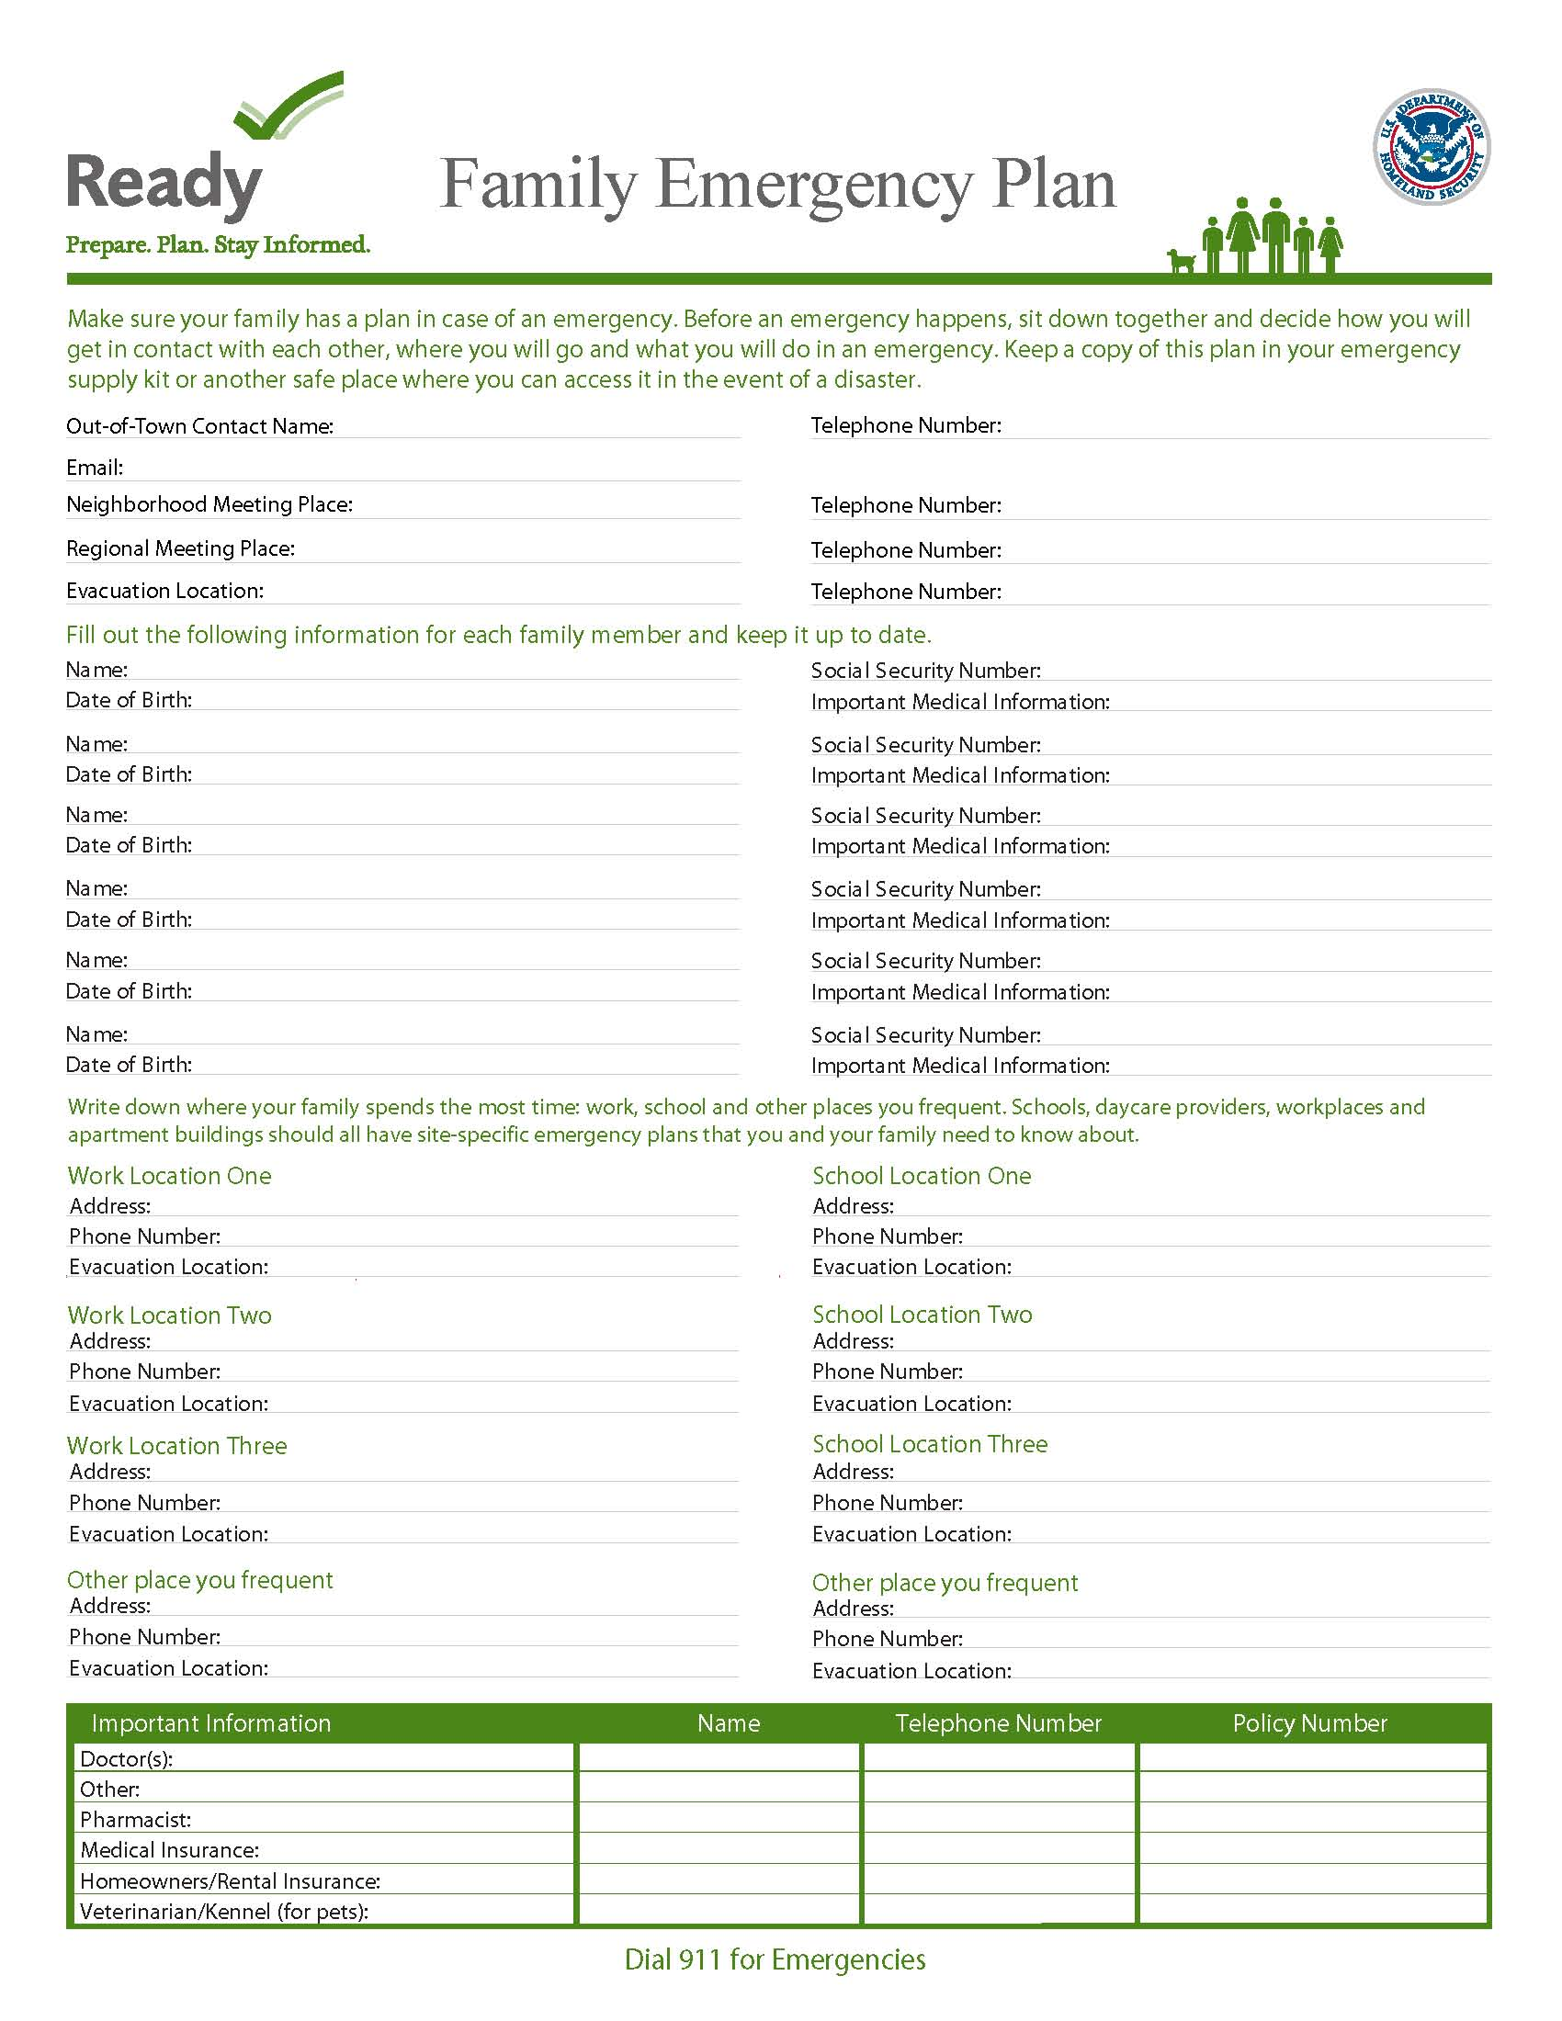

Novel Pandemics https://www.ready.gov/pandemic
A pandemic is a disease outbreak that spans several countries and affects a large number of people. Pandemics are most often caused by viruses such as COVID-19, which can easily spread from person to person.
A novel (new) virus such as COVID-19 can emerge from anywhere and quickly spread around the world. It is hard to predict when or where the next novel pandemic will emerge.
- May be spread directly from person to person.
- May be spread indirectly. Germs can pass from a non-living object to a person.
- May be spread by people who are infected but don’t have any symptoms.
- A vaccine, testing, or treatment for the disease may not exist right away. It may take months or years for the majority of the world to become immune to the disease.

If a Novel Pandemic is declared:
- Wash your hands often with soap and water for at least 20 seconds and try not to touch your eyes, nose, and mouth.
- Keep a distance of at least six feet between yourself and people who are not part of your household.
- Cover your mouth and nose with a mask when in public.
- Clean and disinfect high-touch objects and surfaces.
- Stay at home as much as possible to prevent the spread of disease.
- Follow the guidance of the Centers for Disease Control and Prevention (CDC) and local authorities.
HOW TO STAY SAFE WHEN A PANDEMIC THREATENS

Prepare NOW
- Learn how diseases spread to help protect yourself and others.
- Take actions to prevent the spread of disease. Cover coughs and sneezes. Stay home when sick (except to get medical care). Wash hands with soap and water for at least 20 seconds.
- Plan for schools, workplaces, and community centers to be closed. Investigate and prepare for virtual coordination for school, work (telework), and social activities.
- Create an emergency plan so that you and your family know what to do and what you will need in case an outbreak happens. Consider how a pandemic may affect your plans for other emergencies.
- Gather supplies in case you need to stay home for several days or weeks. Supplies may include cleaning supplies, non-perishable foods, prescriptions, and bottled water. Buy supplies slowly to ensure that everyone has the opportunity to buy what they need. Remember that not everyone can afford to stock up immediately. Consider avoiding WIC-labeled products so that those who rely on these products can access them.
- Review your health insurance policies to understand what they cover, including telemedicine options.
- Create password-protected digital copies of important documents and store in a safe place. Watch out for scams and fraud.

Stay Healthy DURING
- Follow the latest guidelines from the CDC and state and local authorities to prevent the spread of disease. Refer to your local and state public health departments for vaccine and testing updates.
- Maintain good personal health habits and public health practices. Proper handwashing and disinfecting surfaces help to slow the spread of disease. If soap and water are not available, use a hand sanitizer that contains at least 60 percent alcohol.
- Limit close, face-to-face contact with others. Stay at home as much as possible to prevent the spread of disease.
- If you believe you’ve been exposed to the disease, contact your doctor, follow the quarantine instructions from medical providers, and monitor your symptoms. If you’re experiencing a medical emergency, call 9-1-1 and shelter in place with a mask, if possible, until help arrives.
- Practice social distancing while in public. Keep a distance of at least six feet between yourself and people who are not part of your household. Avoid crowds and large groups of people.
- Share accurate information about the disease with friends, family, and people on social media. Sharing bad information about the disease or treatments for the disease may have serious health outcomes. Remember that stigma hurts everyone and can cause discrimination against people, places, or nations.
- Know that it’s normal to feel anxious or stressed. Engage virtually with your community through video and phone calls. Take care of your body and talk to someone if you are feeling upset.

Be Safe AFTER
- Continue taking protective actions, like:
  - Staying home when you are sick (except to get medical care).
  - Following the guidance of your health care provider.
  - Covering coughs and sneezes with a tissue.
  - Washing your hands with soap and water for at least 20 seconds.
- Follow guidance on the re-opening of businesses, schools, community-based organizations, houses of worship, and workplaces.
- Be sure to evaluate your family emergency plan and make timely updates.
- Work with your community to talk about the lessons you learned from the pandemic. Decide how you can use these experiences to be more prepared for future pandemics.

