
State Oral Health Programs
Improve oral health by preventing oral disease, promoting oral health and ensuring access to dental care for all residents within their state.


Why is a State Oral Health Program important?
State Oral Health Programs (SOHP) are located within a state’s public health agency. SOHPs are critical to the success of state oral health improvement efforts and they provide the infrastructure essential to create, implement and evaluate oral health initiatives and policies. The SOHP should be led by a licensed dental professional with public health training and should serve as the full-time dental director.

Why should the dental director be a licensed dental professional with public health training?
Experienced leadership with a background in dentistry and public health is essential for determining priorities, setting agendas, developing plans, making funding decisions and establishing statewide policies. The dental director is also charged with increasing awareness and raising priorities for oral health among a broad constituency, as well as providing expert technical assistance on dental related issues for sister agencies, policy makers, stakeholders and residents, following evidence-based research.

What functions is the State Oral Health Program responsible for?
The mission of a State Oral Health Program (SOHP) is to improve the oral health of those individuals residing within their state by planning, implementing and evaluating programs that prevent oral disease and promote oral health, as well as expand access to dental care. SOHPs do this by:
- Assessing and tracking disease rates and improvements in oral health using proven methods of surveillance including the National Oral Health Surveillance, the Basic Screening Survey, BRFSS and PRAMS.
State Oral Health Program Principles

- Integrating oral health and general health
- Programming for all life stages
- Recognizing and reducing oral health disparities
- Identifying, leveraging and using resources
- Social responsibility to advocate for/serve underserved populations
- Demonstrating an understanding and respect for other professions, their goals and roles
- Respecting diversity and attaining cultural competency, including fostering health literacy
- Dedication to life-long learning and quality improvement
- Creating, supporting and evaluating evidence-based community disease prevention initiatives such as school-based sealant programs, fluoride programs and community water fluoridation.
- Providing expertise, training and technical assistance for program development, effectiveness and sustainability, surveillance and analysis, policy development.
- Advocating for the representation of oral health in the state public health initiatives and plans.
- Promoting access to dental care by supporting community-based programs and health centers through data technical assistance and education.
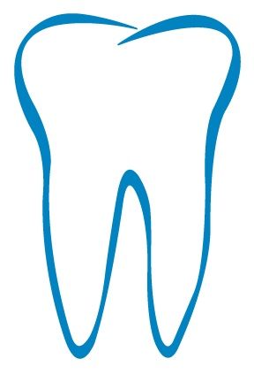
- Facilitating active public/private partnerships, such as educational institutions, the dental board, professional associations, chronic disease coalitions, non-profit organizations, philanthropic organizations, etc. to promote and support good oral health.
- Assuring fiscal oversight including the management of oral health programs within budget constraints, prioritizing potential funding opportunities, prepare proposal to create a diversified funding base.

