Workbook of Steps and Worksheets
to Accompany the Handbook on
Planning, Evaluating, and Improving Collaboration
for Oral Health Programs

Association of State and Territorial Dental Directors
Created in 2012, Revised in 2020
Sparks, NV http://www.astdd.org/collaboration
Funded by CDC Cooperative Agreement 5U58DP001695
Contents are solely the responsibility of the authors and do not necessarily represent the official view of CDC.

Collaboration and Evaluation Improvement Framework (CEIF)
This Workbook contains an overview of the steps and worksheets that correspond to each Collaboration and Evaluation Improvement Framework (CEIF) step outlined in the Handbook and in Worksheet 1. Worksheets are available as downloadable files at http://www.astdd.org/collaboration/
Worksheet 1: Action Step Checklist for the CEIF Steps
Step 1 Determine a Shared Purpose
⎕ Potential partners have examined and compared the goals and objectives of their organizations.
⎕ It is clear to all potential partners why they have chosen to collaborate or not.

Step 2 Raise Collaboration Literacy
⎕ Potential partners recognize and have a shared understanding that collaboration is an imperative, exists in a complex context, is developmental, and involves cycles of inquiry between people.

Step 3 Inventory and Map Communities of Practice
⎕ Partners know who is working with whom and for what purpose.
⎕ All intra-organizational and inter-professional teams have been identified.
⎕ Data generated through the inventory and mapping process is used to inform decision-making about how best to configure/reconfigure teams.

Step 4 Monitor Stages of Development
⎕ Partners recognize the extent to which their alliance is forming, norming, performing, or transforming.
⎕ Partners use monitoring data to inform decisions about how to move the partnership to the next stage of development.

Step 5 Assess Levels of Integration
⎕ Partners understand the current and desired intensity of integration between members of the alliance.
⎕ Data about level of integration is both qualitative and quantitative in nature.
⎕ Data about level of integration informs decision-making about how to strengthen the partnership.

Step 6 Assess Inter-Professional Collaboration
⎕ Key/high leverage teams, central to the core practices of the alliance, are identified.
⎕ The quality of dialogue, decision-making, action, and evaluation is assessed.
⎕ Data regarding the quality of each team’s cycle of inquiry informs decisions about how to improve team collaboration.

Step 7 Develop a Communication Plan to Share Your Findings
⎕ Intended audiences are chosen for the report or other communication channels and materials
⎕ Channels and formats for materials appropriate for the intended audiences are selected
⎕ Communication plan is implemented after prioritizing activities

Step 1. Determining a Shared Purpose
Before thinking about partnerships, answer the following questions about your own program:
- What is the primary reason your program/group exists?
- What is your program’s/group’s mission?
- Do you have a logic model or theory of action?
- Have you developed any objectives or desired outcomes for the project or focus area you want to address?
If you cannot answer these questions, you will need to engage in some basic evaluation strategies before you tackle the complex task of planning to evaluate partnerships. A number of references, tools and examples are listed in the Resources section and Appendix A of the Handbook to help you do this. State oral health programs that need basic evaluation assistance may request some technical assistance from ASTDD (cwood@astdd.org).
When you can answer the previous questions and are ready to proceed, select a project or idea for which you would like to collaborate with other groups. What partnerships might be important to the success of this project or focus? Brainstorm a list of groups that you think might be able to help you accomplish this project or idea.
Now select one or both of the following processes to evaluate your list of potential partners. Use the process (es) and form(s) for one group at a time.
Process Option 1. Determining a Shared Purpose (Worksheet 2a)
Assessment Questions | Group:
What is the group’s mission?
How much and in what ways do your missions overlap or intersect?
Why do you want to partner? What resources or assets could they bring to the partnership?
Is the group stable and viable?
Is it likely that your project/idea will move forward more efficiently and effectively with this group as a partner? | If no, stop here for now. If yes, proceed to the next question
Is there a clear overlap in your vision, mission, value, and goals? | If no, stop here for now. If yes, proceed to the next question.
Do you think your project/idea can only be accomplished or done better if you partner with this group at some level? | If no, don’t select this group at this time. If yes, include as a potential partner for the next step.

Process Option 2. SWOT Analysis (Worksheet 2b)
Group:
Strengths

Weaknesses

Opportunities

Threats

Do Strengths + Opportunities Outweigh Weaknesses + Threats?
Step 2. Raise Collaboration Literacy
Groups need to develop a common language, a shared understanding, and a shared learning process about collaboration to develop and sustain successful partnerships. Decide how you will raise collaboration literacy with your potential partners. Will you accomplish this via a meeting led by a facilitator who is an experienced evaluator, send parts of the Handbook for people to read, or a combination of the two approaches? Make a decision and invite the list of potential partners you developed in the previous step to participate in the learning experience.

Step 3. Inventory and Map Communities of Practice
To inform decisions about how best to configure team membership so that distribution is purposeful and equitable and where to target resources and focus evaluation efforts, you may need to determine existing teams referred to here as Communities of Practice (CoP). Communities of practice, whether they are within an organization or a linking group between agencies, are made up of people and their skills. Effective teams engage in a cycle of inquiry where the team members participate in dialogue, decision-making, action, and evaluation. Some members may be involved in too many communities of practice or there may be redundancy in the mission or scope of work for certain communities of practice. Use the Communities of Practice Inventory Form to record the information (Worksheet 3). This is best done in a group setting.

Name of CoP | Members | Purpose of the Group | Frequency and Location of Meetings | Importance:  4=Essential  3=Important  2=Peripheral  1=Value unknown

Once you have the list, create a visual map to better display the key Communities of Practice so everyone can see where CoPs might overlap.

Step 4. Monitor Stages of Development
Evaluating Early Stages of Partnership Development Forming Stage of Development (Worksheet 4a)
Success in launching a strategic alliance is determined by level of clarity around purpose, structures, strategies, leadership, and tasks that were identified at the beginning of alliance formation. Once your alliance is formed, answer the following questions.

- How is/was the leader identified? ____________________________________________________________________________________________________________________________________________________________
- How are/were members recruited and was enough time spent in the recruitment process?
____________________________________________________________________________________________________________________________________________________________
- How representative is the partnership membership with regard to its purpose?
____________________________________________________________________________________________________________________________________________________________
- Do leaders and members share a common understanding of the alliance’s purpose?
____________________________________________________________________________________________________________________________________________________________
- Does the alliance have the right people and organizations at the table?
____________________________________________________________________________________________________________________________________________________________
- Are leaders’ and members’ roles and responsibilities transparent and understood by all?
____________________________________________________________________________________________________________________________________________________________
- Does each alliance member understand why we are here and what we hope to accomplish?
____________________________________________________________________________________________________________________________________________________________
- Are anticipated linkages between each member’s parent organization and the alliance clearly delineated?
____________________________________________________________________________________________________________________________________________________________

Once the alliance has been assembled, the next stage is creating order and structure for the group and its work. Make sure everyone can answer the questions from the following list that are relevant to your situation and record your answers:
Ordering Stage of Development (Worksheet 4b)
- What is our purpose? What outcomes to do we expect to reach? What are our primary activities? What will indicate to us that we are reaching our goals and outcomes?
____________________________________________________________________________________________________________________________________________________________
- Have we established systems and norms for managing consensus and conflict?
____________________________________________________________________________________________________________________________________________________________
- Are policies and guidelines in place to achieve our purpose?
____________________________________________________________________________________________________________________________________________________________
- Do we have the appropriate bylaws, contract, or other formal or informal agreements in place to govern our partnerships and activities?
____________________________________________________________________________________________________________________________________________________________
- How is information going to be disseminated to members?
____________________________________________________________________________________________________________________________________________________________
- What systems are in place for the budgeting and distribution of resources?
____________________________________________________________________________________________________________________________________________________________
- What processes exist to address the issues of membership turnover?
____________________________________________________________________________________________________________________________________________________________
- How will new members be incorporated into the alliance?
____________________________________________________________________________________________________________________________________________________________
- Have informal leaders begun to emerge?
____________________________________________________________________________________________________________________________________________________________
- How are these informal leaders incorporated into the formal leadership group?
____________________________________________________________________________________________________________________________________________________________
- What benefits and costs do each of us expect to accrue as a result of our participation in the alliance?
____________________________________________________________________________________________________________________________________________________________
- Do the benefits of participation outweigh the costs of membership?
____________________________________________________________________________________________________________________________________________________________

Evaluating Later Stages of Partnership Development

In the performing phase, the partner groups are actively using the various systems that have been established (e.g., communication) and are executing the specific tasks necessary to accomplish the alliance’s goals. Assess the alliance’s progress periodically by asking the following questions and recording the answers.

Performing Stage of Development (Worksheet 4c)

- Do members understand their individual roles in the context of the alliance?
____________________________________________________________________________________________________________________________________________________________
- How have roles and responsibilities shifted over time?
____________________________________________________________________________________________________________________________________________________________
- How successful have members been in putting the goals of the alliance before their own or their organization’s needs?
____________________________________________________________________________________________________________________________________________________________
- How effectively and/or efficiently are the alliance systems (e.g., information dissemination, resource allocation) working?
____________________________________________________________________________________________________________________________________________________________
- Do leaders and members acknowledge and address progress and setbacks?
____________________________________________________________________________________________________________________________________________________________
- How are requirements for additional or different resources identified?
____________________________________________________________________________________________________________________________________________________________
- How are data being used to inform decision-making and to make mid-course corrections?
________________________________________________________________________________________________________
- Are lessons learned used to amend the alliance structures, leadership, and/or process?
_________________________________________________________________________________________________________

In the transforming phase (reaching critical milestones, facing unforeseen events, changing direction, and/or re-forming the alliance), the alliance progresses toward refinement, reformation, or dissolution. Assessment can be done by asking the following questions and recording the responses.
Transforming Stage of Development (Worksheet 4d)
- What goals have been accomplished and how satisfied is the group with its performance?
____________________________________________________________________________________________________________________________________________________________
- What activities have been carried out and how satisfied is the group with these accomplishments?
____________________________________________________________________________________________________________________________________________________________
- What evidence do we have to document our accomplishments?
____________________________________________________________________________________________________________________________________________________________
- How committed are each of the partners to the purpose of the alliance?
____________________________________________________________________________________________________________________________________________________________
- Should membership change? If so how?
____________________________________________________________________________________________________________________________________________________________
- How is the alliance transforming? What factors are precipitating the transformation?
____________________________________________________________________________________________________________________________________________________________
- To what extent do the leaders, members, and external linkages agree with the decision to transform the alliance?
____________________________________________________________________________________________________________________________________________________________
- To what extent do we believe the purpose of the alliance has been fulfilled?
____________________________________________________________________________________________________________________________________________________________
- Should the alliance disband? If so, when? If not, why not?
____________________________________________________________________________________________________________________________________________________________

To assess growth of an alliance, you can also use a Satisfaction Survey. A basic format is included as Worksheet 5 but needs to be adapted for each situation. This example is for an oral health coalition and only uses one category. Consider using questions under the following categories: 1) Planning and Implementation, 2) Leadership, 3) Multiple/Diversity of Perspectives, 4) Communication, and 5) Progress and Outcomes. Use the suggested 5-point Likert rating scale. The downloadable worksheet file includes all the categories.
Satisfaction Survey (Worksheet 5)
Dear Coalition Member:

The purpose of this satisfaction questionnaire is to get your feedback about the quality of our Oral Health Coalition. Please complete each question by checking the box that best shows your satisfaction with that aspect of the coalition. We welcome additional comments and suggestions you have for improving this coalition. Thank you in advance for your valuable advice and feedback.

Planning and Implementation

 |  | 1 Very dissatisfied | 2 | 3 | 4 | 5 Very satisfied
1 | Clarity of the vision for where the coalition should be going
2 | Planning process used to prepare the coalition’s objectives
3 | Follow-through on coalition activities
4 | Strength and competence of staff
5 | Efforts to promote collaborative action
6 | Process used to assess the community’s needs
7 | Training and technical assistance provided by staff
Comments:

Proceed with the same format for the other four categories of questions. Then include this summary section:

OVERALL APPROVAL RATING (1-5—use previous scale):

Is the issue of oral health better addressed today because of this coalition? (Please check one)

Yes ⎕ No ⎕ No basis for judgment ⎕

OVERALL COMMENTS AND SUGGESTIONS FOR IMPROVEMENT:

Step 5. Assess Levels of Integration
There is a wide range of linkages that develop between and within organizations. Collaborative efforts can range across a continuum of low to high integration. Periodic assessments of these levels can help inform decisions about where and how collaborations can be strengthened and evaluate the effectiveness of the alliance linkages as a whole. Assessments can be done by one organization with the rest of the group or among all organizations.
Using the criteria outlined in the Strategic Alliance Formative Assessment Rubric (SAFAR) on the next page, use Worksheet 6 to record your group’s level of integration with at least three other groups.

Strategic Alliance Formative Assessment Rubric (SAFAR)
Adapted SAFAR from: Gajda, R. (2004)
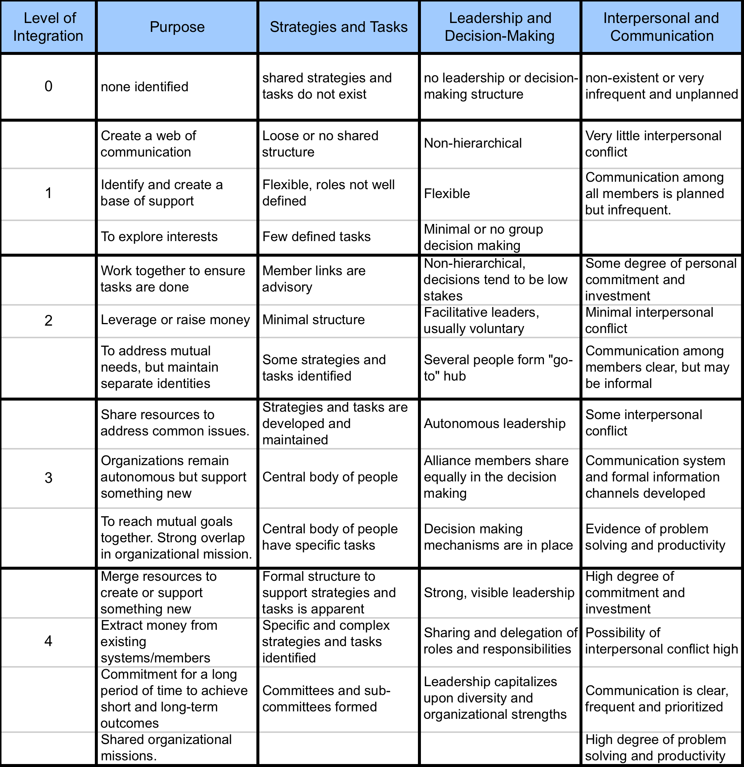
Worksheet 6. SAFAR Ratings of Your Program/Group and Partners

CURRENT (C) and DESIRED (D) LEVELS OF INTEGRATION (0-4) (SAFAR)  Date: | Your Program/Group  Current Desired
Group 1:
Group 2:
Group 3:
AVERAGE CURRENT (C) AND AVERAGE DESIRED (D) LEVELS OF INTEGRATION
You can send the SAFAR and Worksheet 6 to these same partners to solicit their perceptions of levels of interaction with your program or group. Then compare their perceptions to yours to identify any areas for clarification or improvement.

A more complex process is having all of the members of an alliance assess their respective organization’s level of integration with everyone else’s organization (Worksheet 7). This can be done separately with someone summarizing all of the results for a subsequent meeting of the alliance or during an alliance meeting to discuss the findings and identify areas of strength and areas for improvement.
Worksheet 7. SAFAR Alliance Assessment
Current (C) and Desired (D) Levels of Integration  Date: | Group 1 |  | Group 2 |  | Group 3 |  | Group 4 |  | Group 5 |  | Group 6 |  | Group 7
 | C | D | C | D | C | D | C | D | C | D | C | D | C | D
Group 1

Group 2
Group 3
Group 4
Group 5
Group 6
Group 7
Average Current (C) Level Across Alliance: |  |  |  |  |  | Average Desired (D) Level Across Alliance:

Step 6. Assess Inter-Professional Collaboration
Because teams are the predominant unit for decision making and getting things done in any organization or group, it is essential to gauge the quality of dialogue, decision-making, action, and evaluation in each key Community of Practice in your alliance. Review your inventory of the Communities of Practice and then complete the Community of Practice Collaboration Assessment Tool (Worksheet 8.) This can be done by team members using the process options in the tool, by an external evaluator that observes the team meetings, or an external review of meeting minutes. After you complete all 4 domains shown on the following pages (Dialogue, Decision Making, Action and Evaluation), summarize your findings on the last page of the worksheet. This process records current behaviors. The groups can go back later if they want and insert what desired level they aspire to by a certain date.

Community of Practice (CoP) Collaboration Assessment Tool (Worksheet 8)

Name of CoP:

CoP Members:

Date:

Group/Person Completing the Assessment:

Process Used for Administering the Assessment: (check all that apply):

⎕ recollection and reflection by a team member
⎕ observation of team meeting (via video)
⎕ observation of team meeting (in person)
⎕ review and analysis of agendas
⎕ review and analysis of meeting minutes
⎕ review and analysis of performance information
⎕ consultation with individual members(s)
⎕ consultation with specialist(s)
⎕ consultation with administrator(s)
⎕ other ______________________________

Domain 1
Scores |  | DIALOGUE  Record one number per row in the Current (C) column. A number can be added in the Desired (D) column if the alliance wants to do that process later
C | D | 0 | 1 | 2
 |  | There is no pre-planned agenda for group dialogue. | A written agenda for group dialogue exists. | Agenda for team dialogue is pre-planned, written, and distributed.
 |  | Full attendance at team meetings is rare or the group meets sporadically. | Most team members regularly meet face-to-face. | All team members regularly meet face-to-face.
 |  | Team dialogue is improvisational and unstructured. | Occasionally the process for team dialogue is structured. | Team dialogue is guided by a protocol.
 |  | Team meetings do not focus on group practice and performance. | Team meetings are generally related to group practice and performance. | Team meetings are focused on the structured examination of group practice and performance.
 |  | Controversy and disagreements do not exist, or they exist and go unresolved. | Professional tension exists, but controversy is rare and/or may go unresolved. | Professional tension exists, and disagreements are resolved "now" or as close to now as possible.
 |  | Dialogue is almost convivial, or members tend to “dominate” or “hibernate.” | Most team members contribute to the dialogue, but there are “hibernators” and “dominators.” | Members participate equally in group dialogue; there are no "hibernators" or "dominators.”
 |  | There is no record of team dialogue, decisions and intended actions. | A record of team dialogue, decisions, and intended actions exists. | A thoughtful, thorough and accurate account of team dialogue, decisions, and intended actions is recorded and accessible to all team members.
Total C Score:
Total D Score :
Areas of Strength:

Areas for Improvement:

Corrections and Celebrations:

Domain 2
Scores |  | DECISION-MAKING  Record one number per row in the Current (C) column. A number can be added in the Desired (D) column if the alliance wants to do that process later
C | D | 0 | 1 | 2
 |  | The team does not decide what individual and collective practices they will initiate, maintain, develop, and/or discontinue. | The team occasionally determines what individual and collective practices they will initiate, maintain, develop, and/or discontinue. | The team regularly decides what individual and collective practices they will initiate, maintain, develop, and/or discontinue.
 |  | Decisions are not typically informed by face-to-face dialogue in team meetings. | Most decisions are informed by team dialogue in face-to-face meetings. | All decisions are informed by team dialogue in face-to-face meetings.
 |  | The group does not have a process for leadership and/or facilitation | A process for team leadership and facilitation are determined. | A process for team leadership and facilitation is purposefully determined.
 |  | Decision making process does not exist or is not transparent; decisions are rarely made by consensus. | The process for making decisions is informal; most decisions seem to be made by consensus. | The process for making any decision is transparent and adhered to; decisions are most often made by consensus.
 |  | Decisions are not made, or do not relate to the cultivation of identified outcomes, activities, and indicators. | Decisions are tangentially related to the improvement of practice and the cultivation of identified outcomes, activities, and indicators. | Decisions are directly related to the improvement of practice and the cultivation of identified outcomes, activities and indicators.
 |  | Team members do not identify specific instructional practices that they will employ to increase student learning, nor do they identify the strategies they will discontinue. | Team members determine strategies that they will employ to improve performance or the less effective strategies that they will discontinue. | Team members determine specific strategies that they will employ to improve performance and the less effective strategies they will discontinue.
 |  | Individual members make their own decisions regardless of team decision-making. | Most individual team members commit to carrying out team decisions. | Each individual member commits to carrying out team decisions.
Total C Score:
Total D Score:
Areas of Strength:

Areas for Improvement:

Corrections and Celebrations:

Domain 3
Scores |  | ACTION  Record one number per row in the Current (C) column. A number can be added in the Desired (D) column if the alliance wants to do that process later
C | D | 0 | 1 | 2
 |  | Between team meetings individual team members do not take action. | Between team meetings most individual team members take specific action(s) as a result of team decision-making. | Between team meetings each individual team member takes specific action(s) as a result of team decision-making.
 |  | Team member actions are not complex, challenging, or interdependent. | Team member actions are somewhat coordinated and interdependent, complex/challenging. | Team member actions are coordinated and interdependent, complex/challenging.
 |  | Team members do not take action related to the cultivation of identified outcomes, activities, and indicators. | Actions are generally related to the improvement of practice and the cultivation of identified outcomes, activities, and indicators. | Actions are directly related to the improvement of practice and the cultivation of identified outcomes, activities, and indicators.
 |  | Individual members do not employ new strategies intended to increase performance, nor do they discontinue the use of less effective strategies. | Most individual members employ strategies intended to increase performance and discontinues less effective strategies. | Each individual member employs specific strategies that will improve performance and discontinues less effective strategies.
 |  | Distribution of action-taking among team members is unfair/unbalanced. | Distribution of action-taking among team members varies. | There is equitable distribution of action-taking among team members.
Total C Score:
Total D Score:
Areas of Strength:

Areas for Improvement:

Corrections and Celebrations:

Domain 4
Scores |  | EVALUATION  Record one number per row in the Current (C) column. A number can be added in the Desired (D) column if the alliance wants to do that process later
C | D | 0 | 1 | 2
 |  | The team does not collect or analyze qualitative information about their practices and stated outcomes, activities and indicators. | The team infrequently collects and analyzes qualitative information about their practices and stated outcomes, activities and indicators. | The team regularly collects and analyzes systematically collected qualitative information about their practices and stated outcomes, activities and indicators.
 |  | The team does not collect or analyze quantitative information about their practices and stated outcomes, activities and indicators. | The team infrequently collects and analyzes quantitative information about their practices and stated outcomes, activities and indicators. | The team regularly collects and analyzes systematically collected quantitative information about their practices and stated outcomes, activities and indicators.
 |  | The team relies exclusively on “hearsay,” “anecdotes,” and “recollections” to evaluate the merits of their practices. | The team may rely more on “hearsay,” “anecdotes,” or “recollections” to evaluate the merits of their practices. | The team uses performance data to evaluate the merit of their practices.
 |  | Evaluation data and findings are not shared publicly within the team. | Evaluation data and findings are sometimes shared publicly within the team. | Evaluation data and findings are shared publicly within the team.
 |  | Most members on the team do not make evidenced-based improvements to her/his practice. | Most members on the team make evidenced-based improvements to her/his practice. | Every member makes evidenced-based improvements to her/his practice.
Total C Score:
Total D Score:

Areas of Strength:

Areas for Improvement:

Corrections and Celebrations:

Summary of Domain Assessment Scores
 | Current (C) | Desired (D)
Dialogue | /14 | /14
Decision-making | /14 | /14
Action | /10 | /10
Evaluation | /10 | /10
Total | /48 | /48

Key Areas of Strength:

Key Opportunities for Improvement:

Corrections and Celebrations:

Step 7. Develop a Communication Plan to Share Your Findings
Using all of the information you gathered, it is time to report and use the findings. Use Worksheet 9 to plan how you will do this and how you will evaluate the impact of the report and any outcomes from sharing the findings.

Communication Plan (Worksheet 9)
Goal:

Intended Audience(s):

Objectives:

Key Messages:

Channels and Materials:

Pre-testing Messages and Materials:

Activities:

Evaluation Design, Methods and Measures:

Responsible Parties and Partnerships:

Timelines:

Budget/Resources Needed:

Protocol for Review/Approval:

Now go back to Worksheet 1 (CEIF Checklist) to determine if you completed all of the steps in the Collaboration Evaluation and Improvement Framework.

